ADMINISTRATOR TRAINING GUIDE
Costing Policies
A simple guide to company costs, task costs, crew rates, overhead, margins, and exclusions
Purpose: Help administrators understand what each feature does, when to use it, and how it affects an estimate.

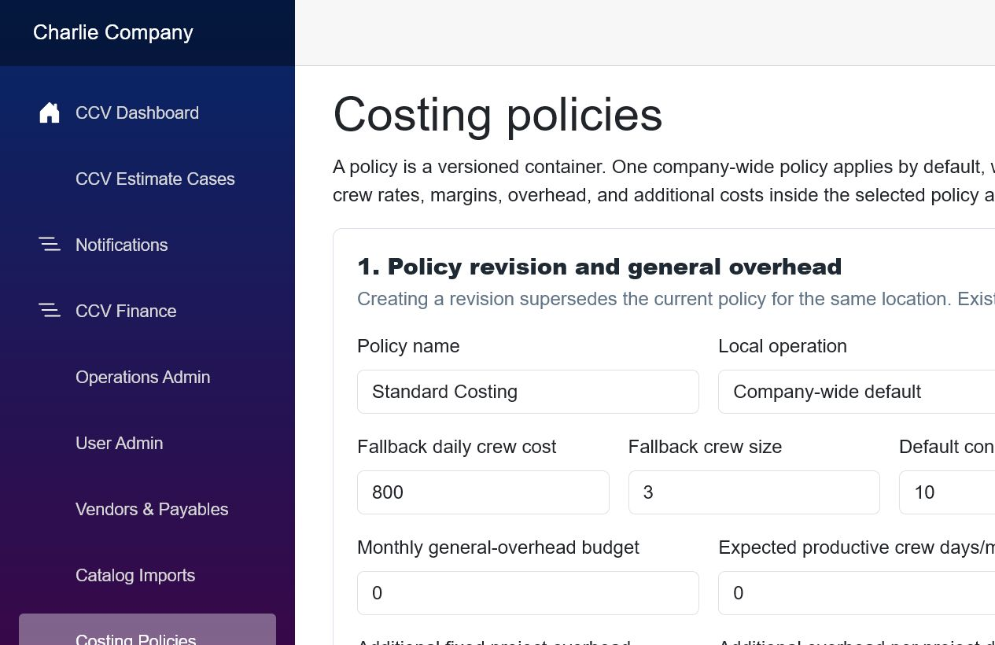
The Costing Policies page begins with the active policy revision and company overhead assumptions.
Who should use this guide
- Administrators who maintain company-wide or local-operation costing assumptions.
- Managers who approve crew rates, overhead recovery, and selling margins.
- Anyone reviewing why a CCV estimate reached a particular cost or suggested selling price.

1. The big picture
The Costing Policies page is a set of pricing instructions. It tells CCV what normal costs to add, which vendor materials to use, what labor costs, what overhead must be recovered, and what margin should be targeted.
Simple rule: Catalogs tell CCV what an item costs. Policies tell CCV which additional costs, crew rates, standard supplies, overhead, and margins must be applied.

How an estimate is calculated
- CentCom proposes materials and quantities from the estimator’s notes and photographs.
- CCV matches those materials to vendor catalog items and current prices.
- Required supply kits add standard items even when the estimator did not mention them.
- Crew rates and project days calculate labor.
- Task and project rules add costs such as permits, mobilization, and disposal.
- General overhead and contingency are applied.
- The applicable task margin produces the suggested customer price.
Pricing flow: Materials + standard supplies + labor + task/project costs + overhead + contingency = estimated cost. The margin rule then determines the suggested selling price.

Company-wide rules and local overrides
- Company-wide default: used by every local operation unless that operation has its own active policy.
- Local-operation policy: overrides the company default for that location.
- Inheritance: a local policy can use company-wide kits, crew rates, margins, and costs when a matching local rule does not exist.
Good practice: Start with a company-wide policy. Add a local override only when a real local cost or pricing difference exists.

Revisions preserve history
A policy is versioned. Creating a new revision makes it the active revision for the same location and effective date. Existing estimate snapshots remain unchanged, which lets administrators explain older estimates later.
Do not edit history: When assumptions change, create a new revision. Do not expect older estimates to recalculate automatically.

2. Policy revision and general overhead

Screen example: the policy container and company overhead assumptions.
This section establishes the policy version and the company costs that must be recovered across all work.
Field | Plain meaning | Simple guidance
Policy name | Name of the policy family. | Use a stable name such as Standard Costing.
Local operation | Where the policy applies. | Choose Company-wide default unless the location truly differs.
Effective date | First day the revision is valid. | Use the date the new assumptions should begin.
Fallback crew cost | Backup daily labor cost. | Used only when no more specific crew rate matches.
Fallback crew size | Backup number of workers. | The daily crew cost is for the whole crew, not each worker.
Default contingency | Allowance for uncertainty. | 10% adds a cushion for normal unknowns; it is not profit.
Fallback margin | Backup selling margin. | Used only when no task-specific margin rule matches.
Monthly overhead budget | Average monthly operating costs. | Examples: office payroll, insurance, rent, software, and vehicles.
Productive crew days | Crew-days expected to produce revenue. | CCV divides monthly overhead by this number.
Additional overhead | Extra fixed, daily, or percent recovery. | Use only for costs not already included in the monthly budget.

Overhead example
If monthly overhead is $17,260.87 and the company expects 50 productive crew-days, CCV allocates $345.22 of overhead per crew-day. A five-day task would recover $1,726.10 before any additional overhead settings.
Avoid double counting: If an expense is already inside the monthly overhead budget, do not also enter it as a fixed or percentage overhead amount.

3. Standard supply kits
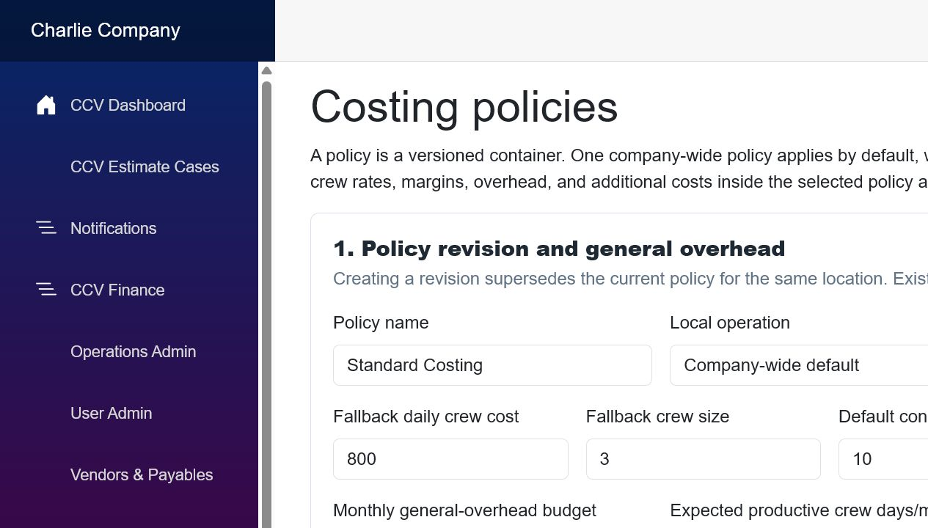
Screen example: required supply kits, crew rate cards, and task margin rules.
A standard supply kit is a repeatable bundle of catalog items that CCV adds automatically to matching work. It solves the problem of ordinary supplies being forgotten because they were not dictated by the estimator.

When to create a kit
- Prepping supplies used on every job of a certain type.
- Cleanup materials, fasteners, blades, tape, plastic, or protective equipment.
- A standard group of items required by a manufacturer’s installation method.

How to create one
- Select the active policy revision.
- Name the kit clearly, such as Deck Build - Standard Consumables.
- Choose the task type and, when useful, the work type.
- Add each catalog item, its standard quantity, and an optional waste percentage.
- Activate the kit after the contents are reviewed.
Example: A New Deck Build kit might add construction adhesive, structural screws, layout string, blades, and cleanup bags to every matching task.

4. Crew rate cards
Crew rate cards assign the normal daily labor cost and crew size for a task type and optional work type.
Field | Plain meaning | Simple guidance
Task type | Broad kind of work. | Deck, roofing, repair/restoration, screen room, and so on.
Work type | More specific work variation. | Use when new construction and restoration need different crews.
Crew size | Expected number of workers. | Used for planning and reporting.
Daily cost | Cost of the entire crew for one day. | $800 for a 3-person deck crew means $800 total per day.

Specific beats general: A matching task-and-work-type rate should win over a general task rate, and a local rate should win over the company-wide rate.

5. Task margin rules
Task margin rules allow different work to target different profit levels. A new deck may support a higher margin than maintenance or restoration.
Field | Plain meaning | Simple guidance
Task type | Work category that receives the margin. | Create one rule per major task type when economics differ.
Work type | Optional narrower match. | Use for New Build, Restoration, Maintenance, or another variation.
Target margin | Percent of selling price left after cost. | This is margin, not markup.

Margin example
If total estimated cost is $10,000 and the target margin is 40%, the suggested price is $16,666.67. A 40% margin is not the same as adding 40% to cost.
Formula: Suggested price = total cost ÷ (1 - margin rate). For 40%: $10,000 ÷ 0.60 = $16,666.67.

Use the fallback carefully: The policy-level fallback margin applies only when no more specific task margin matches. Create task rules for work with meaningfully different market conditions.

6. Additional task and project costs
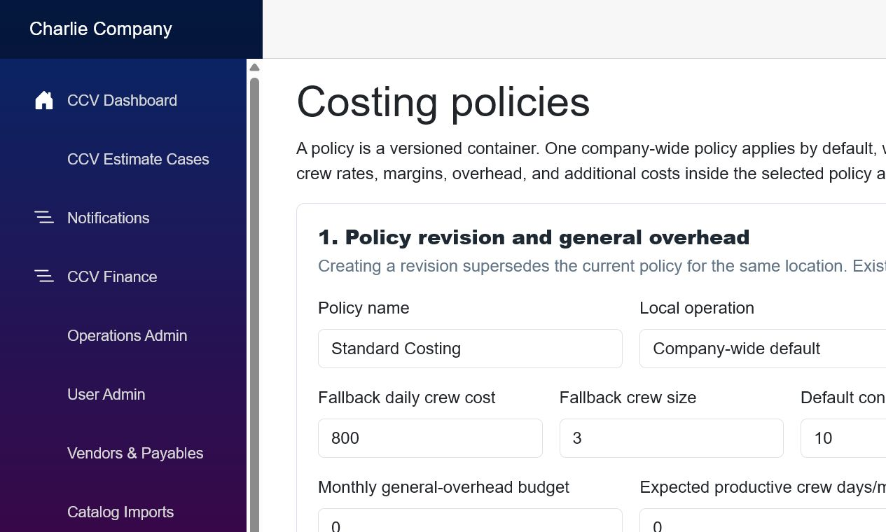
Screen example: additional costs and material exclusions.
These rules add costs that do not belong in a vendor catalog. Examples include permits, disposal, haul-away, equipment rental, delivery, mobilization, and project management.
Field | Plain meaning | Simple guidance
Scope: Task | Applied to each matching task. | A $500 deck disposal rule applies to every matching deck task.
Scope: Project | Applied once to the estimate. | A $750 permit rule applies once even when the estimate has several tasks.
Fixed | One set amount. | Use for a known permit, delivery, or dumpster charge.
Per project day | Rate multiplied by estimated days. | Use for supervision, equipment, or recurring site costs.
% direct cost | Percentage of direct cost. | Use only when the cost reliably scales with the project.

Example: A two-task estimate with a $500 task-level disposal rule could add $1,000. The same $500 rule scoped to Project adds only $500.

7. Material exclusions and recovery mapping
An exclusion tells CentCom and CCV not to treat a matching suggestion as a catalog material. The excluded suggestion stays visible in the audit trail, but it does not enter the material subtotal.

Why a recovery mapping matters
An exclusion by itself removes cost. Therefore, if the cost is still real, the exclusion should point to the policy feature that recovers it: a standard supply kit, an additional cost rule, labor, or overhead.
Field | Plain meaning | Simple guidance
Match phrase | Text to recognize in a suggestion. | Use a stable phrase such as Deck Demolition Consumables.
Task type | Limits where the exclusion applies. | Choose Deck when it should not affect roofing or other tasks.
Recovery method | Where the cost is recovered instead. | Map to a kit, cost rule, labor, or overhead.
Recovery reference | The specific rule or kit. | Select the exact active feature that carries the cost.
Reason | Explanation for administrators. | State why the item is excluded and where its cost is handled.

Critical warning: Never leave a real cost excluded and unmapped. That can make the estimate too low.

Example: demolition consumables
CentCom suggests “Deck Demolition Consumables: Demolition Tools, Safety Gear, and Disposal Bags.” If these are already included in a standard Deck Demolition kit or disposal cost rule, exclude the suggestion and map it to that feature. CCV then avoids charging twice while preserving the audit record.

8. Policy history

Screen example: the active revision is visible in Policy history.
Policy history shows which revision is active and the key assumptions stored in each version. Use it when reviewing an older estimate or confirming that a new revision became active.
- Active means the revision is currently selected for new estimates in that scope.
- Superseded revisions remain available for audit and explanation.
- Existing estimate snapshots continue to use the assumptions captured when they were calculated.

9. Recommended setup sequence
- Create or revise the company-wide policy and enter realistic overhead assumptions.
- Build standard supply kits for supplies that must appear on every matching task.
- Create crew rate cards by task type and work type.
- Create task margin rules for work that supports different margins.
- Add permits, disposal, mobilization, delivery, and other non-catalog cost rules.
- Create exclusions only after the replacement kit or cost rule exists.
- Test one sample estimate for each major task type.
- Review the full cost audit before using the results for a customer estimate.

Administrator review checklist
- ☐ The correct company or local policy is active.
- ☐ The effective date is correct.
- ☐ Monthly overhead and productive crew-days are based on realistic operating data.
- ☐ Crew costs are whole-crew daily costs.
- ☐ Task margins reflect the market and risk of each work type.
- ☐ Standard kits contain active catalog items and reasonable quantities.
- ☐ Task costs and project costs use the correct scope.
- ☐ Every exclusion has a valid recovery method.
- ☐ A sample estimate has been recalculated and reviewed.

Quick glossary
Field | Plain meaning | Simple guidance
Direct cost | Cost directly tied to the work. | Materials, labor, equipment, disposal, and permits.
Overhead | Cost of operating the company. | Insurance, office payroll, rent, vehicles, and software.
Contingency | Allowance for uncertainty. | A cushion for normal estimating unknowns.
Margin | Profit as a percent of selling price. | 40% margin on $10,000 cost produces $16,666.67 price.
Markup | Increase as a percent of cost. | Different from margin; do not enter markup in a margin field.
Revision | A dated version of a policy. | New estimates use the active applicable revision.
Local override | A location-specific rule. | Used only when local economics differ.
Recovery mapping | Where an excluded cost is handled. | Prevents both duplicate cost and missing cost.

Final principle: Every real cost should be counted once, every standard requirement should be automatic, and every pricing decision should be explainable later.

